Managing Performance and Measurement
Guidelines



Table of Contents
1.0 Purpose 3
2.0 Scope 3
3.0 Intended audience 3
4.0 Definitions and Abbreviation 3
5.0 Description 4
5.1 Roles and Responsibility 4
5.2 Guidelines for Performance baselines Maintenance 5
5.3 Guidelines for computing Process Performance Baseline 7
6.0 Guidelines for Developing the Process Performance Model (PPM) 18
6.1 Plan & Track 19
6.2 Data Collection & Analysis 19
7.0 Stakeholder’s Matrix 22
8.0 Revision History 23
9.0 References 23
10.0 Glossary 23

Purpose
The purpose of Managing Performance and Measurement (MPM) guideline document is to provide staff and management with objective insight into how to analyze organization / Projects metrics data, which includes planning, collecting and analyzing organization’s metrics data, assessing process performance, setting organizational targets and identification of improvement opportunities.

Scope
This guideline is applicable to all types of projects.

Intended audience
Intended audience for these guidelines is Senior Management, DH, PO and SQA.

Definitions and Abbreviation
Abbreviation | Description
DH | Delivery Head
PM | Project Manager
PPB | Process Performance Baselines
SEPG | Software Engineering Process Group
SQA | Software Quality Analyst
PPM | Process Performance Model
MPM | Managing Performance & Measurement

Description

Roles and Responsibility
Software Engineering Process Group needs to have the following roles and responsibilities
- SEPG is responsible for efficient and effective institutionalization of all activities related to Managing Performance & Measurement in the organization. This shall be realized through effective organizational level planning, tracking and attaining organizational objectives.
- Providing / arranging for resource training (e.g. in Statistical Process Controls) for effective operations of measurement activities; namely planning, tracking and control of processes and sub-process in the projects and at organizations level.
- Collection of organizational metrics data from all the projects and support functions (SQA,SEPG, Resource Allocation / De allocation, Training, Network Management, Procurement) on periodic basis (monthly)
- Analyze such collected metrics data to identify the workable data for further analysis
- Use of organizational guideline for arriving at the organizational quality and process performance level
- Setting the process average with the upper and lower control limits by referring to the organizational Statistical Process Control techniques
- Publishing the periodic Organizational Process Performance Baselines and process performance models for use by the projects
- Maintaining and tracking the organizational level plan for such baseline publications
- Conduct causal analysis and resolution on the organizational performance trends and identify opportunities for improvement
- Review with the senior management, as part of continual improvement, to consolidate the revised organizational targets based on the above analysis / findings

Guidelines for Performance baselines Maintenance
Plan and Track
- SEPG will be responsible for establishing and maintaining the organizational plan (for Organizational Performance Baseline activities including timely planned release of baselines), which will be tracked through adequate scheduling of the activities. This plan may be a part of Quality Management Plan or otherwise.
- Such plan will be maintained using organizational Configuration Management Methodology.
- Such plan will be updated in line with the organizational decisions from time to time.
Metrics Data Collection (from Projects and Support Functions)
- SEPG will ensure availability of metrics data from the projects and the support functions prior to the release (as planned) of the Organizational Performance Baselines.
- Any ambiguity (on the correctness and the completeness) on the collected data needs to be sorted out by SEPG with the concerned group before processing further.
- SEPG will ensure the accuracy of the data collected.

Metrics Data Analysis using SPC techniques
- Collected data shall be analyzed by SEPG group following the guideline to identify and appropriate treat the outlier data points.
- Data thus collected needs to be analyzed statistically using the organizational guideline to arrive at the process average and the lower / upper control limits.
- Comparisons should use statistical techniques beyond a simple comparison of the mean to gauge the extent of quality and process performance objective achievement. If the quality and process performance objectives are not being achieved, corrective actions should be considered.

Assessing Performance using Quality and Process
- All such process average for all the quality and the process performance (metrics) for the project groups and the support functions need to be consolidated for consideration of the Performance Baselines.
- Determine the current and projected organizational business objectives are being met
- Identify and analyze risks associated with not meeting business objectives
Setting Organizational Targets
- Using standard guidelines on Statistical Process Controls, SEPG will recommend on the target (nominal and upper/lower control limits) for the Organizational performance metrics.
- Prioritization of Business Objectives. Revise the QPPO based on the performance or business need.
- Process Performance measures shall be aligned with QPPO.
- Senior management shall review and approve the targets recommended by SEPG

Improvement Area Identification
- Improvement Areas need to be clearly identified for the performance areas where the actual have fared below the current organizational baselines or variation exists between the two performance baselines based on causal analysis
- Further, the performance area, where there is no trend, also needs to be considered under the improvement area.
- Inputs provided by the SEPG members after review and causal analysis
- Identify potential areas for improvement that could contribute to meeting business objectives

Publication of Reports
- Process Performance Baseline Reports shall be published using the organizational standard templates after approval from the reporting management of the SEPG.

Consolidation of Improvement Actions
- The Process Performance Baseline Reports are reviewed by senior management for current performance, variations and desired target performance.
- Potential improvements are identified to be implemented in the organization.
- All such suggested/ potential improvements are consolidated by the Head Quality for the purpose of planning, piloting, implementing and will traced through the process improvement plan.

Update Reports and Uploading Measurement Repository
- SEPG shall update such released reports with the above corrective and prevention improvement action plan.
- Such reports shall be uploaded by SEPG in the organizational Measurement Repository.

Review with Senior Management
- SEPG will review the entire activities (including the report content and actions there from) connected with Organizational Performance Baselines in the periodic Senior Management Review Meetings (Operational Review Meeting and SEPG meetings).
- All such actions / decisions taken in such review meetings need to be properly tracked till closure by SEPG.

Guidelines for computing Process Performance Baseline
Any process, at the organizational level, needs to be evaluated as to how efficiently and effectively it is meeting the requirements of the overall business models and processes.
To enable such evaluation, it is required to quantify the attributes related to organizational standard processes. This quantification sets in adequate environment, eliminating subjectivity, in setting targets; measuring actual performance-level and finally status accounting the same. This is the fundamental basis for Organizational Performance Base lining approach.
This approach also ensures that once the organizational level target is set for a process, all future activities related to the process shall take this target as the reference for the ensuing activities.
Needless to mention that such base lines need to be reviewed periodically by the senior management team to assess the current performance level, then to see scope for improvement and finally to check the suitability of such processes from business perspective for further continuance or otherwise.
The above concept is realized by the following:
- Periodic release of Process Performance Baselines – a report that carries the current performance picture through the actual performance level of all organizational metrics, depicting the key processes; the current organizational target for the future journey and the identification for improvement areas based on actual performance.
- The above baseline reports also provide the necessary inputs for various process performance model-developments. Example: The effort spent in various phases of a project life cycle shall provide a “Model on Effort Distribution”, which can be used by any future similar project to estimate the effort-requirements.

Planning and Tracking
- The plan for the Process Performance Baseline may be a separate document or may be a part of the Quality Management Plan.
- The plan may be prepared on the basis of a calendar year / or financial year / or as appropriate.
- The plan shall be prepared, baselined, maintained and controlled using the organizational standards for document control.
- The plan shall be made available (with adequate access control) to all users in organizational Process Asset Library / knowledge Base Repository.
- The schedule shall be maintained for tracking the planned activities as per the plan.
- The plan shall address the following:
- Release plan of all the Process Performance Baselines as major milestones over the life of the plan
- All major tasks, associated with each such release (like task allocation of various resources in connection with the release)
- Any other issue and / or project (if any)

Resource
- The resources shall be identified based on the considerations of skill required for effective operations. On need base, the training needs to be suitably arranged.
- The resources shall also include suitable representation from the support functions.
- The resource names shall be communicated formally to the organization by SEPG or such group SEPG assigns the responsibility.

Data Collection for Performance Baselines
While collecting the data from the project and the support groups (manually or through use of Project Plus), standard guidelines for Statistical Process Control and Metrics shall be referred to, while addressing the following:
- Coverage of the entire organizational areas shall be maximized to the extent possible. For effort distribution and utilization metrics, all projects should be considered. For maintenance and enhancement metrics, only profiled projects will be considered.
- Coverage of metrics (in line with the organizational guideline for metrics) shall be maximized to the extent possible
- The outlier data points shall be clearly identified and isolated in advance using the principles of Statistical Process Control
- The completeness and correctness of data points shall be assessed adequately and any issue there from, shall be addressed upfront with the concerned group.

Data Collation for Process Performance Baselines
- Data collation shall be done following the organizational processes (manually or through use of tools) after checking the data integrity.
Performance Baseline Computation
Elaboration of the formulas
- Measures of Central Tendency provide the typical value i.e. the value around which most observations fall. The central tendency is measured by the followings:

- Mean: This is the arithmetic average and shall be used when the frequency distribution shows a reasonably symmetrical pattern (at most moderately skewed pattern). Typical such symmetrical distribution is Normal Distribution, where mean is applicable.
Thus, in a normal distribution, if we have a set of n-data-points, X₁, X₂, … , X_{i}, … X_{n-1} and X_{n}; then
Mean shall be (X₁ + X₂ + X₃ + … + X_{n-1} + X_{n}) / n
In excel, the formula can be directly derived as Average.

Example: For a set of 10 data points 20, 18, 25, 16, 19, 17, 22, 20, 18 and 16, the mean is
(20 + 18 + 25+ 16 + 19 + 17 + 22 + 20 + 18 + 16) / 10 = 19.1
This means 19.1 is the representative typical value around which most of the observations are expected in the distribution from which 10 such random data points are taken.
- Median: This is the value, which divides the distribution in two equal halves. This means if we sort the data, the mid value is the median.
This is used in distributions which are skewed / non-symmetrical cases, the median is used for identifying central tendency.
Median is calculated by “Percentile” technique. The x^{th} percentile gives that value, below which x % of the values lie.
In order to calculate percentiles, we need to sort the data-points (i.e. values) and then take the value in the x^{th} percentage point. Thus if we have 20 observations, the 2nd value represents the 10th percentile.
General Rule is if the distribution is symmetrical (normal distribution) and / or moderately skewed, use mean. If it is heavily skewed (like J shaped), use median.
Quick check for skew ness of distribution: If mean and median are close, the distribution is reasonably symmetrical and normal distribution rules apply.

- Measures of Dispersion tell us about the average distance of data points (in a data set) from its central tendency. This measure gives us an input with respect to the spread in data.

- Standard Deviation (SD): Specifies the spread of data. This is calculated as
σ = Sqrt ((1 / (n – 1)) (Σ (X_{i} - X-bar)² ))
Where X_{i} is the i^{th} value of n data points (X₁, X₂, …, X_{i}, … X_{n})
X-bar is the arithmetic mean i.e. (X₁ + X₂ + X₃ + … + X_{n-1} + X_{n}) / n
This SD can be easily calculated using excel or scientific calculator.
- Control Limits: Sigma levels are parameters, which are used for setting up the control limits in any control chart.

Example: If there is a distribution which is close to a normal distribution, then the central line for the control chart shall be the Mean (The central tendency for the distribution). Now to set up the upper and lower control limits, the sigma levels are assigned. A very commonly used limit is 3s, which is called setting 3 sigma limits. Here,
Central Line is at Mean
Upper Control limit is at +3s
And Lower Control Limit is at –3s
Such a process shall ensure that 99.7 % chances of data points falling within the control limits and thus gives an indication of confidence level of success factor in a process.
Thus assigned sigma level sets the control limits line and decides the success factor (confidence level) for the process.
Importance of Sigma Level
The following table indicates how the number assigned to a sigma level influences the confidence level for success factor in a process. Higher is the number; the better is the process (meaning the dispersion is less)
#σ | Success Factor  In the Process
1σ | 68%
1.28σ | 80%
1.64σ | 90%
1.96σ | 95%
2σ | 95.5%
3σ | 99.7%

Selecting Distribution Type
- Organizational metrics shall be calculated from the raw data, as submitted by the project and support groups either manually or through use of tool following the organizational guideline for Metrics.

- Once the data is consolidated, outliers should be identified and removed. It should be supported by rational to identify and remove the data points.

- Normality check needs to be done to check the behavior, whether it is following normal distribution or non-normal distribution.

- Steps to do the Normality test
  - State the null and alternative hypotheses
  - Use the appropriate graphical tool to evaluate data
  - Choose the Anderson-Darling test
  - Run the test
Example:

- Once the actual metrics data points are available, the standard guideline for Statistical Process Control shall be referred to while addressing the following areas:
- Following considerations shall be given for any metrics data-type to arrive at the appropriate model
  - Typical values (Central Tendency)
  - Range of variation (Dispersion)
  - Distribution of values over Range (standard deviation)
  - Probability of occurrence in the Range (sigma levels)
- Generally Normal Distribution is used to set the central line (Mean) and Lower / Upper Control Limits (+/- nσ, where n is 1,2,or 3, ... as decided by the organization based on target the confidence interval of process.
- However, distribution other than Normal Distribution may be considered depending on the nature of metrics data-type.
Test for Equal Variance
Testing for equal variances may be done
- To compare variation in the output of two or more processes
- To test the assumption of equal variances before proceeding with additional hypothesis tests ( e.g.,ANOVA)
When comparing variances, select the proper test statistic
- Normal data: F-test (2 variances), Bartlett’s ( 2 or more variances)
- Non-normal data: Levene’s ( 2 or more variances)
Example:

Analysis of Performance
For Normal Distribution: Setting Central Line and Control Limits
- For setting the central line and the upper / lower control limits, the organizational guideline for Statistical Process Control shall be referred. For Normal Distribution, they are μ and +nσ / -nσ.
- Statistical recommendation is +/- 3σ, however for software industry provides a very wide variation in the process performance. Therefore organizations tend to take 1σ for the purpose of control limits even though it provides on 68% confidence interval.
- Sometimes, percentile-techniques are used to set the boundaries. This is based on the required confidence level on the process-performance. Example: 25th and 75th percentiles may be used for setting up boundaries for some metrics.
An Example Calculation for XmR Chart
To evaluate the day to-day variation of effort spent on servicing the existing product in an organization. It is suspected that different factors may influence activity levels on different days of the week and that there may be differences from week to week. Because day-to-day variation lies at the heart of his question, XmR chart would be used

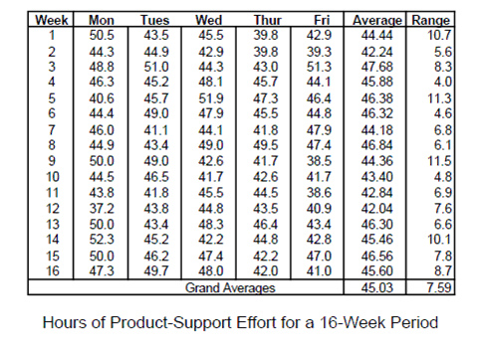

Week | Effort | mR | Week | Effort | mR
1 | 50.5 |  | 9 | 50 | 2.6
1 | 43.5 | 7 | 9 | 49 | 1
1 | 45.5 | 2 | 9 | 42.6 | 6.4
1 | 39.8 | 5.7 | 9 | 41.7 | 0.9
1 | 42.9 | 3.1 | 9 | 38.5 | 3.2
2 | 44.3 | 1.4 | 10 | 44.5 | 6
2 | 44.9 | 0.6 | 10 | 46.5 | 2
2 | 42.9 | 2 | 10 | 41.7 | 4.8
2 | 39.8 | 3.1 | 10 | 42.6 | 0.9
2 | 39.3 | 0.5 | 10 | 41.7 | 0.9
3 | 48.8 | 9.5 | 11 | 43.8 | 2.1
3 | 51 | 2.2 | 11 | 41.8 | 2
3 | 44.3 | 6.7 | 11 | 45.5 | 3.7
3 | 43 | 1.3 | 11 | 44.5 | 1
3 | 51.3 | 8.3 | 11 | 38.6 | 5.9
4 | 46.3 | 5 | 12 | 37.2 | 1.4
4 | 45.2 | 1.1 | 12 | 43.8 | 6.6
4 | 48.1 | 2.9 | 12 | 44.8 | 1
4 | 45.7 | 2.4 | 12 | 43.5 | 1.3
4 | 44.1 | 1.6 | 12 | 40.9 | 2.6
5 | 40.6 | 3.5 | 13 | 50 | 9.1
5 | 45.7 | 5.1 | 13 | 43.4 | 6.6
5 | 51.9 | 6.2 | 13 | 48.3 | 4.9
5 | 47.3 | 4.6 | 13 | 46.4 | 1.9
5 | 46.4 | 0.9 | 13 | 43.4 | 3
6 | 44.4 | 2 | 14 | 52.3 | 8.9
6 | 49 | 4.6 | 14 | 45.2 | 7.1
6 | 47.9 | 1.1 | 14 | 42.2 | 3
6 | 45.5 | 2.4 | 14 | 44.8 | 2.6
6 | 44.8 | 0.7 | 14 | 42.8 | 2
7 | 46 | 1.2 | 15 | 50 | 7.2
7 | 41.1 | 4.9 | 15 | 46.2 | 3.8
7 | 44.1 | 3 | 15 | 47.4 | 1.2
7 | 41.8 | 2.3 | 15 | 42.2 | 5.2
7 | 47.9 | 6.1 | 15 | 47 | 4.8
8 | 44.9 | 3 | 16 | 47.3 | 0.3
8 | 43.4 | 1.5 | 16 | 49.7 | 2.4
8 | 49 | 5.6 | 16 | 48 | 1.7
8 | 49.5 | 0.5 | 16 | 42 | 6
8 | 47.4 | 2.1 | 16 | 41 | 1

The 80 data points in provide a sequence that we can use to construct the individuals and moving range charts. From the data, we find the average staff hours per day (X) and the average two-point moving range (mR) to be

X=45.03 and mR =3.38

The computations then proceed as follows:

- Center line (average of individual values) CLx =45.03
- Upper control limit UCLx =54.01

- Lower Control limit LCLx =36.05

- Center line or average moving range CL mR =3.38

- Upper control limit for moving range UCL R =11.03

The results of these calculations are plotted with the data on the control charts as follows

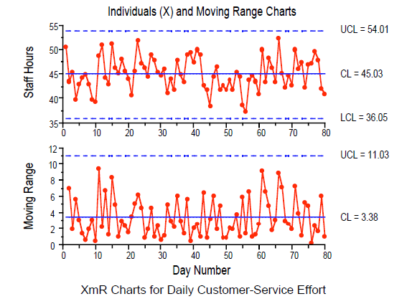

For Non-Normal distribution
The non-normal distribution will be analyzed using the following Non-parametric test:
- Levene’s test
- 1-Sample Sign
- Mann Whitney
- Mood’s Median/Krushal-Wallis
Mann-Whitney Testing
The Mann Whitney test is a statistical test used to compare the medians from two random samples to determine if they are from the same population (ie. The medians are equal) or from different populations (the median are different)
Example: Mann Whitney test Results
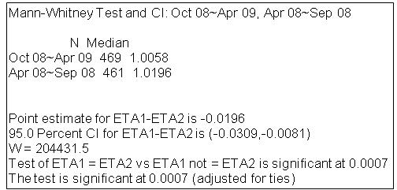

Interpreting Analysis and Recommending Improvement Actions
Based on the analysis criteria, as set above, the following guidelines shall be used to arrive at the optimal interpretation and the consequent recommendation, which forms the basis for Continual Process Improvement:
Analysis Criteria | Interpretation | Actionable Recommendations | Remarks
Current performance | Basis for the current Organizational Performance Baselines | Set the organizational target | Must be highlighted in the baseline report
Low Performance Areas | Needs to pull up | Communicate results to the concerned  Ask for time bound “Improvement Plan”
Process Instability / Non-Trendy | Needs investigation | Investigate, at organizational level, into process definition and / or institutionalization | Major concern for the organization
Non Availability of Data | Issue - Practice / Discipline or Process is the bottle-neck | Counseling (Practice) / Process Review (Definition)
Performance Trend | Is “process / quality” improving or not? | If not, investigate at organizational level, into process definition and / or institutionalization | May be process automation or new technology is the answer

Finalizing Organizational Performance Baseline
The organizational baselines shall be finalized with the senior management group after presentation of the recommended baselines as derived above. Once finalized, after due considerations of senior management from business perspective, the same is used to set/ revise the Organizational target for the subsequent periods and planning of projects for statistical control.
Reporting Organizational Performance Baseline
The reporting shall be done using the organizational performance baseline template where the following areas shall be covered:
- The baseline report shall start with an executive summary highlighting the followings:
- Organizational targets for all the metrics for the coming period
- Current organizational performance for all the metrics with respect to the previously set organizational targets
- Areas where the performance needs to be pulled up
- Areas for Improvements as a result of the following:
    - Current processes do not show a trend and show signs of instability
    - Very few data points are available
- The report shall also highlight for all metrics the followings to get a better understanding on the trend
    - Trend over the last period (say quarter if the reporting is quarterly)
    - Trend over the last 2 periods (say moving annual)
    - Each trend chart shall give the following information:
      - The central line

Release of Organizational Performance Baseline
The baseline shall be released only after consolidating the followings:
- Outcome of review with senior management with recommendations
- Consolidating the improvement action points (both corrective and preventive) from the operational groups

Related Activities:
Managing Configuration Management
- SEPG will follow configuration management practices as per the Configuration Management Guideline (or otherwise as defined explicitly in the Quality Management plan).
- The above practices shall cover all items/work products regarding the entire activities connected with Organizational Performance Baselines

Involve Stakeholders
- SEPG shall involve all the stakeholders time based and / or need based including senior management for the effective functioning of the entire activities connected with Organizational Performance Baselines

Train Resources and Maintain Effectiveness of Operations
- SEPG will evaluate from time to time the training needs of the resources for effective role-playing. Such needs shall include areas like Training on QPM, Statistical Process Control and Metric computation.
- SEPG shall evaluate from time to time the effectiveness of such operations. Such approach shall include periodic audit through IQA.

Guidelines for Developing the Process Performance Model (PPM)
PPM relates a behavior of a process or sub-process to an outcome. It predicts future outcomes based on possible or actual changes to factors. It uses one or more sub-processes to conduct the prediction, the factors used for the analysis are controllable so that project may take action to influence outcome. These factors are statistical and probabilistic in nature rather than deterministic. Specifically, the Process performance models predict quality and performance outcomes from factors related to one or more sub-processes involved in the development, maintenance or service processes.
PPM will be developed at the project level using the data specific to the project. The tools like Cystal Ball will be used to develop Process Performance Model.
Recommended Prediction Models
- Monte Carlo Simulation
- Bayesian Belief Networks (BBNs)
- Discrete Event Process Modeling and Simulation
- Time Series Analysis
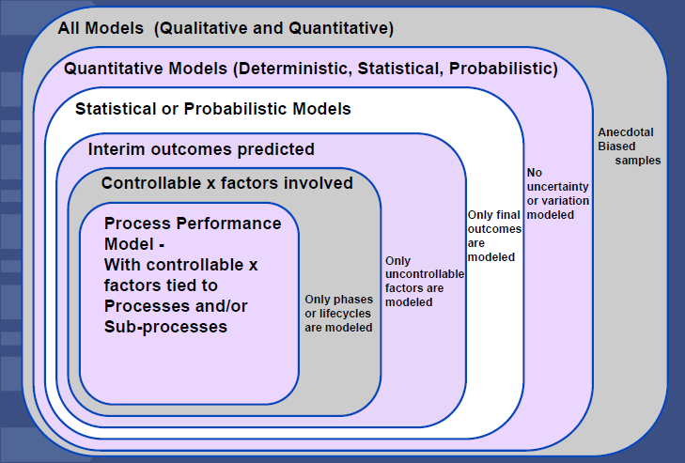

Plan & Track
Identify / select the process performance model on the basis of type and nature of the project

Data Collection & Analysis
Consolidate the data for the project or the group from the organizational database.
- Segregate the data for the similar kind of work and
- Correlation Regression analysis need to be done prior to PPM to define the relationship between Output (Y) and Inputs (X’s). Plotting Scatter plot is helpful to find if there is any non-linear relationship exists.
- Normalize the data
- Identify and remove the outliers supported by rational
- Define the assumptions for the development of process performance model
- Identify & fit the distribution of the data. Distribution describe the variation in process factors, if no distribution is found then use the triangular distribution

Following are the examples of distributions you may come across:
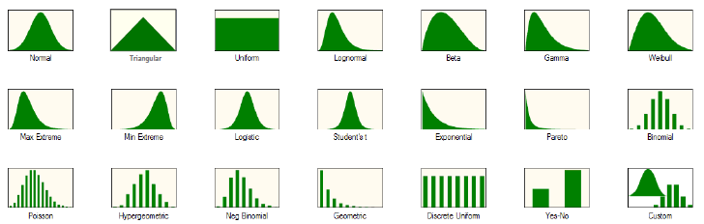
- Perform analysis for Process performance baselines (PPB) for the identified type of task and come up with the natural tolerance limits. Generally the baselines are at sub process level
- Use the PPB values to build the Process performance models (PPM) for the project. Generally the sub-process parameters are referred to as "Input Variable". Identify the forecast parameter required for the project and define the relationship of the forecast parameter with the sub process parameters
- Identify the process options in the project and redefine if necessary the relationship between the forecast and the sub-process parameters.
- Run simulation for all the process options and choose the one which provides the desired value to the forecast.
- After establishing PPM, Hypothesis Testing shall be used to validate the same. If we fail to reject null Hypothesis, it implies that PPM holds good for the Process.
- Identify the sensitive sub-process, which is contributing maximum for the variability of the process using sensitivity chart
- Control chart will be plotted for the most sensitive sub-process for the project
- Establish the PPM for stable process only
- Recalibrate the model in every six months or on event driven basis

Monte Carlo Simulation
Allows modeling of variables that are uncertain (e.g. put in a range of values instead of single value) . Enables more accurate sensitivity analysis . Analyzes simultaneous effects of many different uncertain variables (e.g. more realistic) . Eases audience buy-in and acceptance of modeling because their values for the uncertain variables are included in the analysis . Provides a basis for confidence in a model output (e.g. supports risk management)

Bayesian Belief Network
Bayesian belief networks are powerful tools for modeling causes and effects in a wide variety of domains. They are compact networks of probabilities that capture the probabilistic relationship between variables, as well as historical information about their relationships. Bayesian belief networks are very effective for modeling situations where some information is already known and incoming data is uncertain or partially unavailable (unlike rule-based or “expert” systems, where uncertain or unavailable data results in ineffective or inaccurate reasoning). These networks also offer consistent semantics for representing causes and effects (and likelihoods) via an intuitive graphical representation. Because of all of these capabilities, Bayesian belief networks are being increasingly used in a wide variety of domains where automated reasoning is needed.

BBNs are more flexible because probabilistic modeling does not require adherence to all standard statistical assumptions. BBNs enable modeling of both objective and subjective data .BBNs perform both forecasts of future performance and diagnosis of root causes of today’s process performance issues. BBNs can operate with incomplete information whereas statistical modeling requires that all factors have data collected and reported .BBNs may be setup to have learning mechanisms from real-time project data.

Most simply, Bayes’ rule can be expressed as:

where P(a) is the probability of a, and P(a|b) is the probability of a given that b has occurred.

Structure of Bayesian belief network :-

Graphically, Bayesian belief networks are models in which each variable is represented by a node, and causal relationships are denoted by an arrow, called an edge.
- Nodes :-
  - A node represents a variable in the situation being modeled. A node is often represented graphically by a labeled oval. The simple example in Figure 4 shows two nodes, Precipitation and Road Conditions.
- Edges :-
  - An edge represents a causal relationship between two nodes. It is represented graphically by an arrow between nodes; the direction of the arrow indicates the direction of causality.
- States :-
  - The values taken on by a variable (represented by a node) are referred to as states.
- Conditional probability tables :-
  - Every node also has a conditional probability table, or CPT, associated with it. Conditional probabilities represent likelihoods based on prior information or past experience
- Beliefs and evidence :-
  - Beliefs are the probability that a variable will be in a certain state based on the addition of evidence in a current situation. A-priori beliefs are a special case of beliefs that are based only on prior information. A-priori beliefs are determined only by the information stored in the belief network’s CPTs.

  - Evidence is information about a current situation. There are 2 kinds of evidence

- Hard Evidence
Evidence that a node is 100% in one state, and 0% in all other states.

- Soft Evidence
Any evidence that is not hard evidence. In other words, evidence that a node is less than 100% in one state, and/or greater than 0% in other states . Soft evidence is often used for information about which there is some uncertainty, such as from conflicting reports or an unreliable source.

Stakeholder’s Matrix
Activity/ Process | MD | Sr. Mgmt | Qual Head | Qual Lead | SQA | Proj Owner | Proj Lead | Proj Team
Establish and Maintain definition of Measurements |  |  | A | R | S | C | I | I
Establish Organizational Objectives | A | C | R | C | S | I | I | I
Establish Projects Objectives |  | A |  | C | C | R | S | I
Collect and Analyze Project's metrics data |  |  |  | S | S | C/A | R | S
Apply statistical Control to projects critical parameters (sub-processes) |  | A |  | S | C | R | S | I
Share results with project stakeholders |  | I |  |  |  | R | S | I
Collect and Analyze Projects' metrics data |  |  | A | R | S | C | I | I
Establish Baselines and Models | A | C | R | S | S | S | I | I

R | Responsible | Person who owns the problem/project
A | to whom R is Accountable | He or she must sign or approve the work before it is OK
S | can be Supportive | Can provide resources or can play a supporting role in implementation
C | Should be Consulted | has information and/or performance necessary to complete the work
I | Should be Informed | must be notified of results, but need not be consulted

Revision History
Version | Date | Author | Reason for Change
1.0 | 12.08.2024 | PEG- Head | Baseline version

References
  - Procedures & Guidelines
- Metrics Handbook
- Measurement and Analysis Process
- PPM for Development Project
  - Additional References
Capability Maturity Model® Integration (CMMI-DEV), Version 3.0

Glossary
None.

